
CO1-AT2-Data Interpretation Exercise
M.ARSHINI [192424322]
DSA0601- Data Handling and Visualization
Data Interpretation Assessment (R Programming)
Topics:
• Mapping Data onto Aesthetics
• Coordinate Systems and Axes
• Color Scales
Instructions: Use the given dataset to write an appropriate R program, generate the required visualization, and answer the questions.
Question 1: Mapping Data onto Aesthetics
Dataset
Product P1  P2  P3  P4  P5  P6 | Sales (₹ Lakhs) | Profit (%) | Category  Electronics Clothing  Electronics Furniture  Furniture  Clothing
 | 120 | 18
 | 90 | 12
 | 150 | 25
 | 80 | 8
 | 135 | 22
 | 100 | 16

1 Write an R program to create a scatter plot with Sales on the x-axis and Profit on the y-axis.
CODE:
library(ggplot2)
data <- data.frame(
Product = c("P1","P2","P3","P4","P5","P6"),
Sales = c(120,90,150,80,135,100),
Profit = c(18,12,25,8,22,16),
Category = c("Electronics","Clothing","Electronics", "Furniture","Furniture","Clothing") )
ggplot(data, aes(x = Sales, y = Profit,
color = Category,
size = Sales)) +
geom_point(alpha = 0.8) +
labs(title = "Sales vs Profit",
x = "Sales (Lakhs)",
y = "Profit (%)") +
theme_minimal()
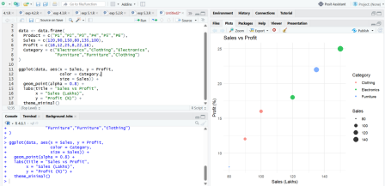2 Map Category using an appropriate aesthetic and Sales using another suitable aesthetic.
• Category → Color, Sales → Point Size
3 Interpret the relationship between Sales and Profit.
• Higher sales generally correspond to higher profit, indicating a positive relationship.
4 Identify the type of scale used for each variable.
• Sales – Continuous scale
• Profit – Continuous scale
• Category – Categorical (Discrete) scale
5 Suggest one alternative visualization that better represents the same data. • Bubble Chart
Question 2: Coordinate Systems (Cartesian and Polar)
Dataset
Direction  N | Frequency
 | 18

NE  E  SE  S  SW  W  NW | 12
 | 20
 | 15
 | 22
 | 11
 | 16
 | 14

Questions
1. Write an R program to visualize the dataset using a Cartesian coordinate system.
Cartesian Coordinate System Code
library(ggplot2)
data <- data.frame(
Direction = c("N","NE","E","SE","S","SW","W","NW"), Frequency = c(18,12,20,15,22,11,16,14)
)
ggplot(data, aes(Direction, Frequency)) +
geom_col(fill = "steelblue") +
labs(title = "Directional Frequency (Cartesian)") + theme_minimal()
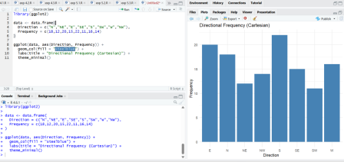
2. Write another R program to visualize the same data using a Polar coordinate system.
Polar Coordinate System Code
library(ggplot2)
data <- data.frame(
Direction = c("N","NE","E","SE","S","SW","W","NW"),
Frequency = c(18,12,20,15,22,11,16,14)
)
ggplot(data, aes(Direction, Frequency, fill = Direction)) + geom_col() +
coord_polar() +
labs(title = "Directional Frequency (Polar)") +
theme_minimal()
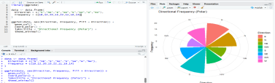
3 Compare the effectiveness of both visualizations.
• Cartesian is easier for comparing values, while Polar better represents directions. 4 Explain which coordinate system is more appropriate for directional data.
• Polar coordinate system.
5 Justify your answer based on data interpretation.
• Since the data represents compass directions, the circular layout matches the natural orientation of directional data.
Question 3: Color Scales for Data Representation Dataset
Student  A  B  C | Marks
 | 45
 | 58
 | 72

Student  D  E  F | Marks  81  67  90

Questions
1. Write an R program to create a bar chart using a sequential color scale based on Marks.
CODE:
library(ggplot2)
data <- data.frame(
Student = c("A","B","C","D","E","F"),
Marks = c(45,58,72,81,67,90)
)
ggplot(data, aes(Student, Marks, fill = Marks)) + geom_col() +
scale_fill_gradient(low = "lightblue",
high = "darkblue") +
labs(title = "Student Marks") +
theme_minimal()
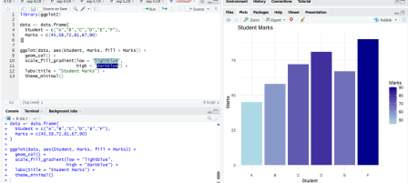2. Identify the students with the high
• Highest: Student F (90)
• Lowest: Student A (45)
3. Explain why a sequential color scale is appropriate.
• Sequential color scales represent increasing numerical values clearly.
4. Suggest a color palette suitable for color-blind users.
• Viridis palette.
5. Explain the difference between sequential and categorical color scales. • Sequential Scale → Used for continuous numeric values.
• Categorical Scale → Used for different categories.
Question 4: Highlighting with Color
Dataset
Region North  South  East  West  Central | Revenue (₹  Crores) 820  760  790  1010  770

Questions
1. Write an R program to create a bar chart highlighting the region with the highest revenue.
CODE:
library(ggplot2)
data <- data.frame(
Region = c("North","South","East","West","Central"), Revenue = c(820,760,790,1010,770)
)
data$Highlight <- ifelse(data$Revenue ==
max(data$Revenue),
"Highest","Others")
ggplot(data,
aes(Region, Revenue,
fill = Highlight)) +
geom_col() +
scale_fill_manual(values = c("Highest"="red", "Others"="gray")) + labs(title = "Regional Revenue") +
theme_minimal()
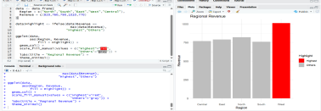2. Explain how highlighting improves data interpretation.
• Highlighting immediately draws attention to the most important value. 3. Identify the highest-performing region.
• West Region (₹1010 Crores)
4. Discuss how excessive use of colors can affect interpretation. • Too many colors can confuse users and reduce readability.
5. Suggest one alternative highlighting technique other than color. • Use labels or annotations.
Question 5: Integrated visualization dataset
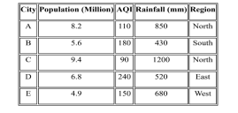
1. Write an R program to create a bubble chart using appropriate aesthetic mappings.
CODE:
library(ggplot2)
data <- data.frame(
City = c("A","B","C","D","E"),
Population = c(8.2,5.6,9.4,6.8,4.9),
AQI = c(110,180,90,240,150),
Rainfall = c(850,430,1200,520,680),
Region = c("North","South","North","East","West") )
ggplot(data,
aes(x = Population,
y = AQI,
size = Rainfall,
color = Region)) +
geom_point(alpha = 0.7) +
labs(title = "Population vs AQI",
x = "Population (Million)",
y = "AQI") +
theme_minimal()
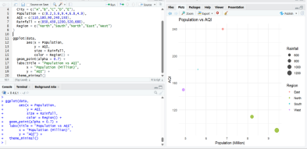
2. Select suitable aesthetics for Population, AQI, Rainfall, and Region. • Population → X-axis
• AQI → Y-axis
• Rainfall → Bubble Size
• Region → Color
3. Interpret the relationship between Population and AQI.
• Cities with higher population generally tend to have higher AQI, though the relationship is not perfectly linear.
4. Identify the continuous and categorical variables.
• Continuous Variables
➢ Population
➢ AQI
➢ Rainfall
• Categorical Variable
➢ Region
5. Recommend one improvement to enhance the visualization's readability. • Add data labels to identify each city and improve readability.

